

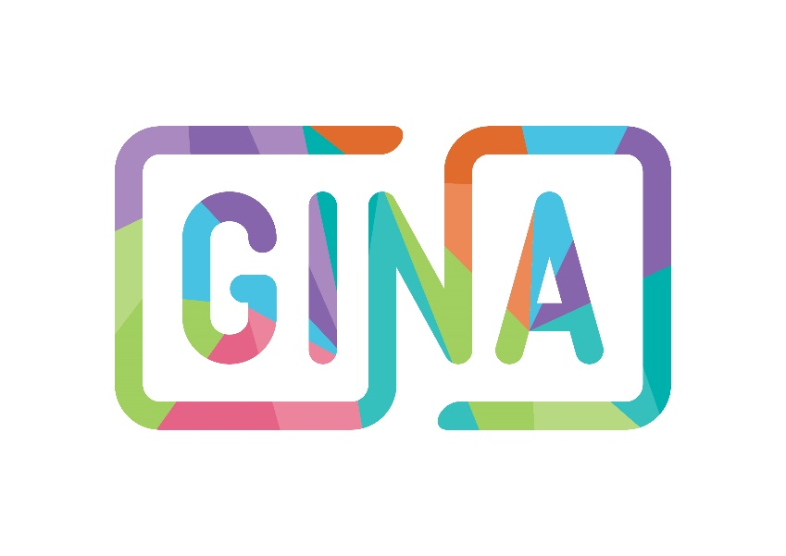
- Role Description
- Person Specification
- Application Form
- How to apply
- Recruitment & Selection Statement
- Welcome Letter
- Our Mission, Vision & Values
- About GINA

Twitter: @GINA_CIC
Instagram: @gina_cic
Facebook: @gain.cic.uk
0121 643 0301
hello@gina.uk.com
www.gina.uk.com
Closing Date: 31st March 2025
Lead Digital Design Ambassador
Applicant Information Pack
This pack includes:


Recruitment & Selection Statement

GINA is a UK social enterprise united by lived experience to bring compassionate, tailored counselling & bespoke products/resources for all subjected to sexual violence & abuse. We are a colourful, growing organisation. If you thrive off creativity & have a passion for supporting individuals subjected to sexual violence & abuse, we’d love to hear from you!

GINA is committed to equality and valuing diversity.

This includes a commitment within our recruitment & selection processes, where we are welcoming applications from across the community & are actively encouraging applicants with a protected characteristic to join our team.

GINA believes that lived experience is vital and central to everything that we do.

We are committed to ensuring that individuals subjected to sexual violence and abuse are involved at every level of our organisation. Therefore, we welcome applications from individuals with lived experience of sexual trauma who also meet the person specification, so we can work together, engage and amplify voices throughout all our work.

GINA is committed to ensuring the safety of the individuals we support. More details can be found in our Adult & CYP Safeguarding policies (available upon request).


GINA, Grosvenor House, 7th Floor
14 Bennetts Hill, Birmingham, B2 5RS
www.gina.uk.com | hello@gina.uk.com

Welcome Letter

Dear Applicant

Thank you for your interest in joining GINA. I am pleased to enclose an Applicant Information Pack which includes further details.

Care in completing the Application Form will help us to give your application the consideration it deserves; naturally, this will be treated in the strictest confidence. Guidance Notes to help you complete the Application Form are included. Please also complete the Equal Opportunities Monitoring Form, along with your Application Form.

If you would like any further background information about our organisation and our work. Please visit www.gina.uk.com. If you would like to discuss this position further, please contact me on hello@gina.uk.com.

Should you hear nothing from us by 30th April 2025, you may assume that you have been unsuccessful on this occasion. However, please do not les this deter from applying to work for GINA in the future.

Please email the completed Application Form and Equal Opportunities Form to me on hello@gina.uk.com by 5pm on the 31st March at the latest.

Yours sincerely,

Lucy Hebberts
Head of GINA



Mission & Vision

our vision
a world revolving with hope & compassion to hold individuals subjected to sexual violence & abuse in their truth & embrace individuals in living into their power.

our mission
to step into shared power, in celebration of individuality, compassion & connection to support all subjected to sexual violence & abuse in living hopeful futures; while challenging beliefs, attitudes & systems that facilitate sexual violence & abuse.

our social mission
uniting in lived experience to enhance a compassionate, curious & tailored approach to support for individuals subjected to sexual violence & abuse everywhere.
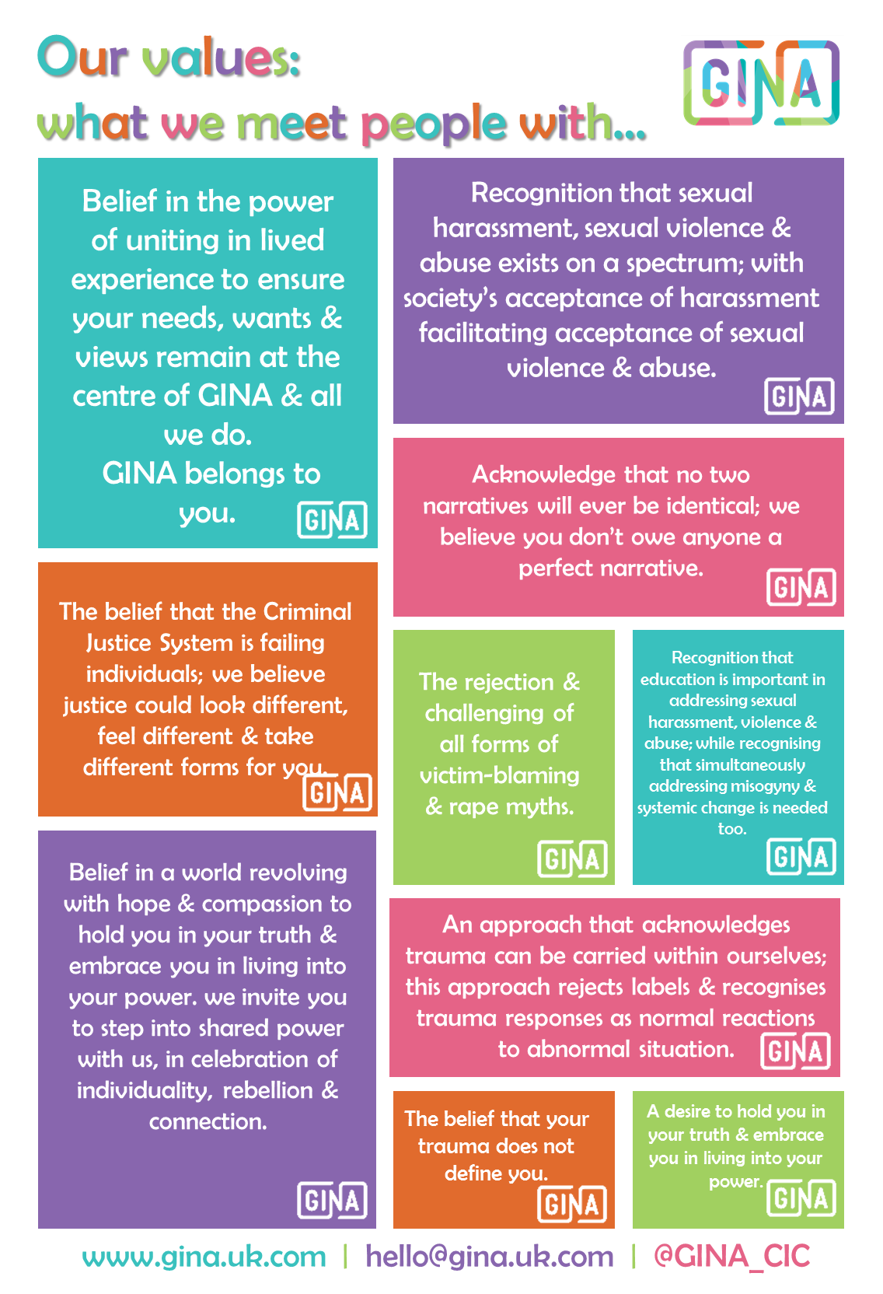

About GINA

Led by individuals with lived experience of sexual trauma, GINA is a social enterprise & community interest company providing private, immediate specialist counselling & bespoke products/resources for individuals subjected to sexual violence & abuse. GINA provides immediate counselling support – there is no waiting list for our support (contrasting lengthy waiting lists associated with organisations providing free support). There is no equivalent UK private, specialist, rape crisis organisation.
We also have ongoing volunteering & fundraising opportunities, alongside opportunities for individuals within our community to get involved with our work.
GINA is the sister organisation of RSVP (the Rape & Sexual Violence Project), a Birmingham-based charity providing free sexual abuse services. As a social enterprise, all GINA profits are donated to RSVP to help fund free specialist support services for individuals who need them.
We support individuals who have been subjected to any kind of sexual trauma, violence &/or abuse, no matter when it happened. We understand how trauma can impact individuals emotionally & physically. We know that feelings of anger, shame & mistrust are natural responses to sexual violence & abuse. We take an approach that recognises experience, understands responses to experiences that are overwhelming as normal, rational & often really sensible, explores stories, rejects labels, seeks to redress power imbalance & builds upon foundations of empowerment and connection. Instead of labelling individuals or the ways they’ve have coped with sexual violence & abuse, GINA will focus on their strengths, how these helped them survive & explore how they can be built on.
Our Story
GINA was established after our Founder, Lisa Thompson, discovered that her much loved grandmother, Nana Gina, was raped as a teenager & had kept this secret for nearly 70 years, only disclosing shortly before she died. Lisa named GINA after her Nana to leave a positive legacy for her & for individuals like her. Lisa vowed that GINA would create opportunities for individuals subjected to sexual violence & abuse to Grow, Inspire, Nurture and Achieve, to encourage people to believe in themselves, their resourcefulness & their potential.
GINA is not a charity – there are already incredible charities out there, providing much needed & valuable services. GINA offers something different & collaborates with individuals in the development of resources, products & events. At the heart of GINA’s philosophy is the belief that everyone, with the right compassionate support & opportunities, can move beyond surviving to thriving after trauma.
Explore more about GINA HQ & our people.
Our services,
products & resources

Head to GINA HQ to explore our:

Counselling support
Products & goodies
Free resources
GINA blog
Our GINA magazine: the oriGINAl
Volunteering, fundraising
& involvement opportunities


Our strategy & priorities

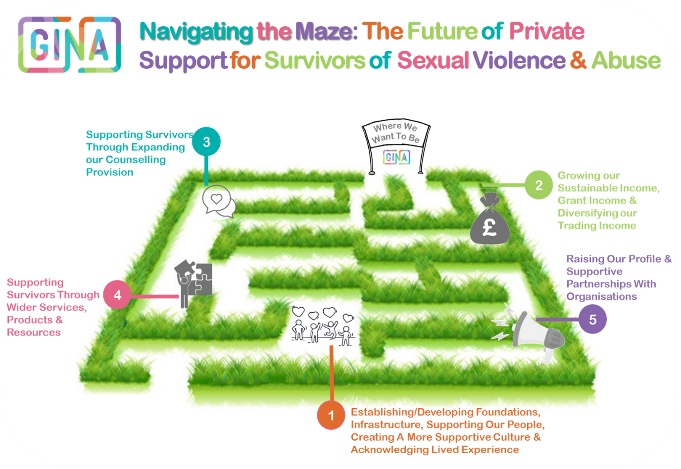
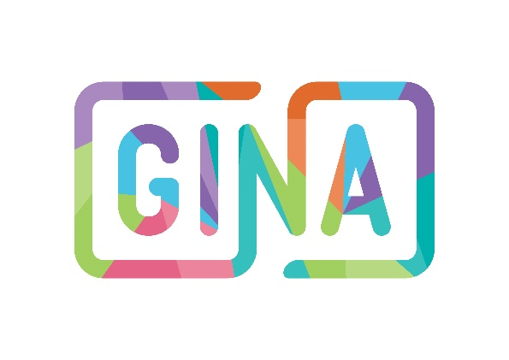
Lead Digital Design Ambassador
Role Description
Please note, this is a voluntary position.

Summary & How the Role Makes a Difference
GINA is currently seeking a Lead Digital Design Ambassador (in accordance with our recent branding re-vamp) to support the design of our digital communications in raising awareness of our organisation, promoting our services/products/resources & enhancing our profile so individuals who may need us are aware of our support.

Description
Do you have experience in digital design, marketing & social media?
Are you a digital whizz who is bursting with creative ideas?
Ready for your next step in a new & rewarding digital design role, supporting individuals subjected to sexual violence & abuse?
We’re looking for a passionate individual with experience in design & digital skills to lead on our digital design. You will support us in developing our digital communications, marketing/social media content, creative resources, audio/video/visual communications & other art mediums (graphic design, illustration, photography etc). You will be supported by a team of Volunteer Ambassadors.

Salary: Voluntary

Hours of work: 8 hours a week - fully flexible

Location: Remote

Responsible to: GINA Support Leads

Main Duties & Responsibilities

Marketing & Social Media
The development of creative marketing materials & social media content to promote GINA’s work. This may include (but is not limited to):
- The creation of marketing materials & campaigns to promote GINA’s services, products & resources
- Creative idea exploration to ensure innovative approaches to GINA’s marketing efforts
- The development of content for GINA’s social media platforms (including Instagram reels & for TikTok)
- The development of all content/materials in alignment with GINA’s branding guidelines

Creative Communications

- The development of creative, artistic & innovative content
- The design of our bespoke resources to support individuals subjected to sexual violence & abuse
- Using different mediums for design (graphic design, illustration, animation, photography, painting, drawing etc)
- Creating audio & visual content (ie. podcast/audio recordings, videos etc)

General
- A creative & innovate approach
- Proficiency in graphic illustration software (including Canva & Adobe Photoshop etc)
- Proficiency in digital editing software (ie. audio/visual editing & formatting)
- Working with GINA’s Support Leads & Volunteer Ambassador Team to implement activities
- Ensuring lived experience remains centred within all activities & continuously exploring opportunities for involvement & infusion of lived experience

Skills & Experience Required
Digital design; proficiency in graphic design, audio/visual editing software; creativity/artistic approach; marketing; content creation

Training & Development Opportunities offered
Ongoing training & development opportunities surround access to specialist training exploring the impacts of sexual violence & abuse & supporting individuals offered by our sister organisation, RSVP. You will also have access to ongoing training opportunities surrounding business/social enterprise management, marketing, social media, fundraising & leadership.

This role description will be subject to review in the light of changing circumstances & may include other duties & responsibilities as may be determined. It is not intended to be rigid or inflexible but should be regarded as providing guidelines within which the individual works.
This role is subject to an enhanced DBS check - application to DBS will only be submitted if offered the position

Our Offer To You

Flexible opportunity to suit your needs & availability
The opportunity to gain experience in graphic/digital design, marketing, communications & social media
The chance to be involved in key decisions surrounding GINA’s graphic/digital design, along with the ability to observe the direct impact of your work
The opportunity to showcase your creativity & explore your ideas in practice
Experience of working within a non-profit
The opportunity to work towards a cause your passionate about
The opportunity to use all your GINA work/projects to build a portfolio for future employment prospects
The opportunity to meet new people & work collaboratively
The opportunity to develop new skills & enhance your CV
Access to training & development opportunities
The opportunity to make a change

Essential / Desirable  Any offers of appointment will be conditional on staff committing to completing training in those areas deemed essential to the post | Method of  Assessment
 | A | I | E
Qualifications and training
Good standard of education, degree or equivalent experience | X
Employment History
Previous or current employment / voluntary experience surrounding graphic/digital design (desirable) | X | X
Skills and experience
Experience in marketing, communications, social media &/or public relations | X | X | X
Experience in graphic/digital design | X | X | X
Experience in visual & audio editing/formatting (& experience in associated software) | X | X | X
High standards of practice and presentation of work | X |  | X
Strong verbal & written communication skills | X |  | X
Excellent organisational skills with an ability to prioritise own workload, deal with competing demands, work to deadlines, prioritise & multi-task |  | X
Able to demonstrate resourcefulness, initiative, problem-solving skills & attention to detail | X | X
Highly computer literate–proficiency in graphic design illustration software (ie.Canva, Photoshop etc) | X
Knowledge of the sexual violence and violence against women & girls sectors (desirable) | X | X
Personal attributes
Self-motivated, ability to manage own varied workload & work as part of a team | X | X
A passion for supporting individuals subjected to sexual violence & abuse & an interest in working for a social enterprise | X | X
Ability to work in an empathic manner & develop a safe supportive relationship, rapport & alliance with individuals we support & colleagues | X | X
Alignment with GINA’s anti victim-blaming, trauma-responsive, compassionate values & demonstration of commitment to GINA’s mission, vision & values | X | X | X
Be self-sufficient & have a naturally proactive nature | X | X
Creativity & the ability to think ‘outside the box’ | X | X | X
Flexible & willing to take on ad-hoc tasks | X | X
Special requirements:
Eligible to work in the UK | X
An Enhanced DBS check- (we will carry out our own check) |  | X
(This form indicates how the requirements will be assessed during the selection process).
A - Application form I - Interview E – Exercise
Lead Digital Design Ambassador
Person Specification


Guidance Notes:
Completing Your
Application Form

Thank you for considering this opportunity with GINA. These notes are meant to help you decide if you want to apply and to improve your chances of being invited for an interview.

Please read ALL the information contained within this pack before you fill in the form.

The Role Description tells you the work you will do if you are appointed.

The Person Specification is very important. It tells you what skills, knowledge and experience you will need to be able to do the job.

Decisions on who to invite for interview are based on what you put on your Application Form - make sure you show how (with examples) you meet each of the criteria identified in the Person Specification.

DON'T FORGET that where you are asked for details of relevant experience, it doesn't just mean paid work. You can back up your statements with examples of what you have done in the past either at home, school or college, in paid work or unpaid work, or as a hobby. For example:-

- Running a home may involve a range of skills like organising and budgeting;
- Being active in a club, tenant's group or other voluntary organisation may show skills like teamwork, communicating or service delivery.

GENTLE REMINDERS:
- Use the application form - we will not consider CVs, resumes, etc.
- Use continuation sheets if you need to - but make sure they have your name on
- Make sure you show how you meet all the criteria in the Person Specification.
- Please remember to complete the Equal Opportunities Monitoring Form since this information helps us to check that everyone is being treated fairly.
- Please make sure that your Application Form is returned in good time for the closing date since forms received after the closing date cannot normally be considered.
- If your application is unsuccessful you can always request feedback by telephoning or writing and please do not be discouraged from applying for other vacancies.

Once again, thank you for your interest and good luck with your application.

Surname: Click or tap here to enter text. | Forename(s) : Click or tap here to enter text.
Any former names: Click or tap here to enter text.
Home Address:
Click or tap here to enter text.
Postcode:
Click or tap here to enter text.

E-mail Address: Click or tap here to enter text. | Home / Mobile Tel No: Click or tap here to enter text.
NI number: Click or tap here to enter text. | Work Tel No: Click or tap here to enter text.
Are you related to anyone at GINA?  ☐ Yes ☐ No  If yes, please give details  Click or tap here to enter text. | In order that GINA may consider reasonable adjustments, are you a disabled person, as defined by the Equality Act 2010 (I.e. do you have a physical or mental impairment which has a substantial and long term adverse effect on your ability to carry out day to day activities)?  ☐ Yes ☐ No
I order that GINA can fully consider any reasonable adjustment required to enable a disabled person to carry out the duties of a post please:

- give details of any adjustment you may need to help you carry out the duties of the post applied for
Click or tap here to enter text.

- give details of any special arrangements you will need (e.g. wheelchair access, sign language interpreter) if invited for interview.
Click or tap here to enter text.

Please note, a disability or health problem does not preclude full consideration for the job, and applications from all suitable applicants are welcome. All information provided by applicants will be treated as confidential.
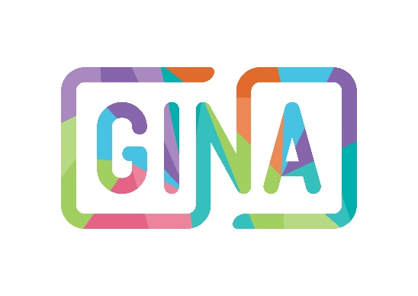
Application Form
Personal Information
Present and Previous Employment
Application Form

What is your present job title?  Click or tap here to enter text. |  |  | Duration employed in this position (years/months)  Click or tap here to enter text.
Name and address of employer  Click or tap here to enter text. |  |  | Current salary/grade  Click or tap here to enter text.
Nature of business
Click or tap here to enter text.
Notice required
Click or tap here to enter text.
Please describe your role in the organisation and outline your responsibilities
Click or tap here to enter text.

Please list your previous appointments with the most recent first (please include details for any long periods of unemployment)
Name and address of employer: | Position held: | Employment start date & end date: |  | Reason(s) for leaving:
Click or tap here to enter text. | Click or tap here to enter text. | Start date:Click or tap here to enter text. End date:Click or tap here to enter text. |  | Click or tap here to enter text.
Click or tap here to enter text. | Click or tap here to enter text. | Start date:Click or tap here to enter text. End date:Click or tap here to enter text. |  | Click or tap here to enter text.
Click or tap here to enter text. | Click or tap here to enter text. | Start date:Click or tap here to enter text. End date:Click or tap here to enter text. |  | Click or tap here to enter text.
Click or tap here to enter text. | Click or tap here to enter text. | Start date:Click or tap here to enter text. End date:Click or tap here to enter text. |  | Click or tap here to enter text.
Please continue on a separate Word Document (or on an additional sheet at the end of this Application Information Pack if needed), with clear indication of the question/section being answered.
Secondary School(s) | Qualifications gained (with grades attained)
Click or tap here to enter text. | Click or tap here to enter text.
College/University/correspondence course (state if full or part time)  Click or tap here to enter text. | Qualifications gained (with grades attained)  Click or tap here to enter text.
Name and type of membership of professional body
Click or tap here to enter text.

Job related training courses attended & dates of award/qualification/certification attained

Click or tap here to enter text.

Application Form
Education

Training

Please continue on a separate Word Document (or on an additional sheet at the end of this Application Information Pack if needed), with clear indication of the question/section being answered.
This section of the Application Form is for you to demonstrate how you meet the requirements of the Person Specification and to explain why you are applying for the job. You must ensure that you show that you meet all of the Criteria from the Person Specification.

Click or tap here to enter text.

Experience
Application Form

Please continue on a separate Word Document (or on an additional sheet at the end of this Application Information Pack if needed), with clear indication of the question/section being answered.
We require candidates to provide details of two referees and preferably both should be qualified to comment on your work performance in the last 3 years, particularly in relation to the person specification/competencies required.

One of your referees must be your present or last employer. We will not contact your present employer prior to an offer of appointment without your permission. If you have not previously been employed then Head Teachers / College Lecturers etc are acceptable as referees. Friends and relatives are not acceptable referees.

In addition, GINA reserves the right to approach any other previous employer or manager.

References will be taken up for the appointable candidate once an offer of employment has been made; therefore, you should ensure that your referees are in a position to respond promptly.

If you were known to your referee by a different name, please indicate your previous name.

All appointments are subject to satisfactory references. GINA reserves the right to terminate any offer of employment or employment contract if the references prove to by unsatisfactory.

A. Click or tap here to enter text. | B. Click or tap here to enter text.
If your present employer is not named as a referee, do you have any objections to their being asked for a reference?  ☐ Yes ☐ No | More information on how we request references can be found in our Recruitment Policy (available upon request).
Referees
Application Form
Declaration
Application Form

Where did you hear about this role? (please tick all relevant answers)
☐ BVSC | ☐ The Survivors Trust | ☐ From an existing GINA team member
☐ Changemarker Jobs | ☐ Word of Mouth | ☐ Through a University
☐ Another organisation (please specify):  Click or tap here to enter text. | ☐ Social media (please specify):  Click or tap here to enter text. | ☐ Other (please specify):  Click or tap here to enter text.

Self-disclosure form: criminal history
We invite you to disclose any criminal records, pending criminal proceedings or suspended sentences here:
Click or tap here to enter text.

Disclosure and Barring Service (DBS)

All individuals working at GINA, on a paid or voluntary basis, will undergo a DBS check of criminal records. This check must be completed before your work at GINA commences. GINA will always complete our own DBS check, regardless of checks that have been made by other organisations. These checks will be updated every three years and staff are to disclose to their line manager or Designated Safeguarding Lead any information which may subsequently show up on DBS checks once employment has commenced. Staff must also disclose if they are living in the same household where another person who is disqualified lives or is disqualified ‘by association’ as specified in regulation 9 of the Childcare (Disqualification)Regulations 2009 as made under section 75 of the Childcare Act.

I declare that, to the best of my knowledge and belief, all statements contained in this form are correct. I understand that should I conceal any material fact, I will, if engaged, be liable to the termination of my contract of employment.
Providing false info is an offence and could result in the application being rejected or summary dismissal (and possible police referral) if your application is successful.

Signed:  Click or tap here to enter text. | Date:  Click or tap here to enter text.

All information contained in the Application Form will be processed in accordance with our Data Protection Policy.
Application Form

Additional Sheet
Section/Question: | Continuation of answer:
Click or tap here to enter text. | Click or tap here to enter text.


If you would like any other background information about our organisation and our work, please visit www.gina.uk.com
If you would to discuss this position further, please contact Lucy via hello@gina.uk.

Please email this Applicant Information Pack (containing a completed Equal Opportunities Form & Application Form)
To Lucy on hello@gina.uk.com by 5pm on the 31st March 2025 at the latest.


How to Apply
for taking the time to work through this Applicant Information Pack. We’re excited to receive your application.


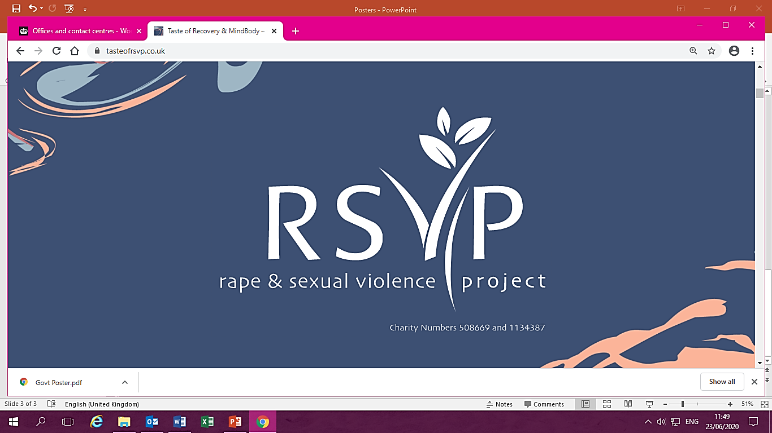
www.gina.uk.com | hello@gina.uk.com | 0121 643 0301

Twitter: @GINA_CIC
Instagram: @gina_cic
Facebook: gina.cic.uk
LinkedIn: GINA CIC
Tik Tok: GINA_CIC
Spotify: The GINA Project CIC
info@rsvporg.co.uk
www.rsvporg.co.uk
Services Line: 0121 643 0301
Helpline: 0121 643 4136

